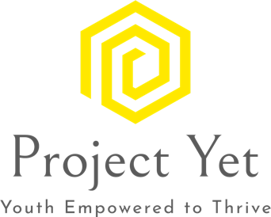

Resourcing Young Adults

Supportive services bridge the gap for young adults as they work towards independence. Resources are provided to young adults based on need and availability,

* Grocery store and restaurant gift cards for young people who are food insecure.
* Gas cards, Uber vouchers to assist with transportation needs.
* Donated toiletries, household items, and clothing.
* Financial support for deposits on places to live.
* Financial assistance for work related or school related supplies.
* Medical co-pays, assistance with the costs of prescriptions.
* Emergency funds for temporary shelter.
* Used and refurbished mobile phones, computers, tablets.
* Bicycles
* Vouchers for Haircuts

When a young person receives financial resources from Project Yet they are required to ‘give back” in volunteer hours.

Reach out at [info@projectyet.org](mailto:info@projectyet.org) for more information